Identifying the impact of trans IL-6 signaling on UTI severity and presence of renal scarring

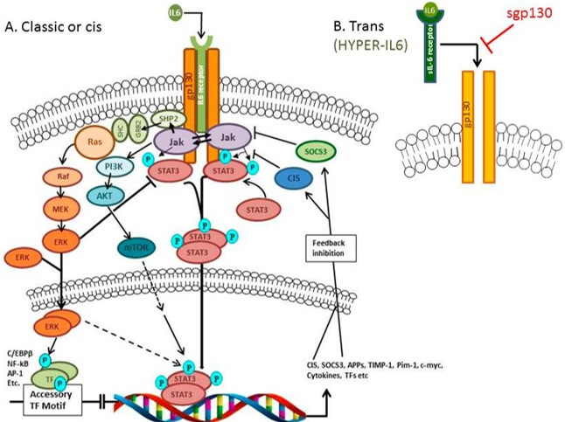

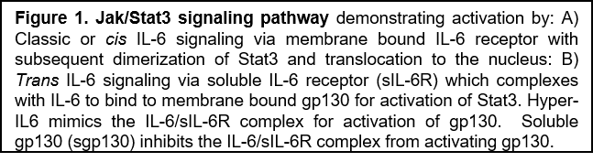

The host inflammatory response is crucial to prevent dissemination of microbial pathogens, yet rampant inflammation can give rise to chronic, irreversible injury. Nowhere is this more evident than in childhood urinary tract infection (UTI) were inflammation serves an important first role in bacterial clearance but can subsequently lead to end organ damage.¹ How the inflammatory response is regulated between these two opposing outcomes in the face of UTI is unknown.

Interleukin-6 (IL-6) is an important cytokine in the inflammatory response and undergoes marked induction during human UTI. While IL-6 expression is important in bacterial clearance in UTI, it is also associated with pyelonephritis and the development of renal scarring. Emerging data indicate that the fine tuning of the IL-6 response is essential to prevent IL-6 driven inflammation and scarring. The pro-inflammatory roles of IL-6 are attributed to its association with soluble IL-6 receptor (sIL-6R), a phenomenon known as trans signaling. In contrast, association of IL-6 with IL-6R at the cell surface (cis signaling) has an anti-inflammatory effect.⁴ We hypothesize that the trans IL-6 signaling pathway is critical to UTI severity in children and is involved in the resulting renal scarring as a result of dysregulated inflammation. We propose to test this hypothesis in the following specific aims:

Specific Aim 1: Measure soluble regulators of IL-6 trans signaling in urine and serum of children with acute cystitis and pyelonephritis.
Specific Aim 2: Measure soluble regulators of IL-6 trans signaling in urine and serum of children with acquired renal scars secondary to pyelonephritis.

Our long-term goal is to ultimately prevent UTI, renal inflammation, and scarring, through pharmacologic strategies that specifically modulate the IL-6 trans signaling pathway.

